**AdvocateKhoj**

**Client Module**

**Navigations:**

**My Cases ---- Live cases**

**---- Deleted cases**

**---- Post New case**

**Message Center ---- Inbox**

**---- Sent Items**

**My Profile ---- Profile Information**

**---- Change Password**

**Post New Case - Case Study**

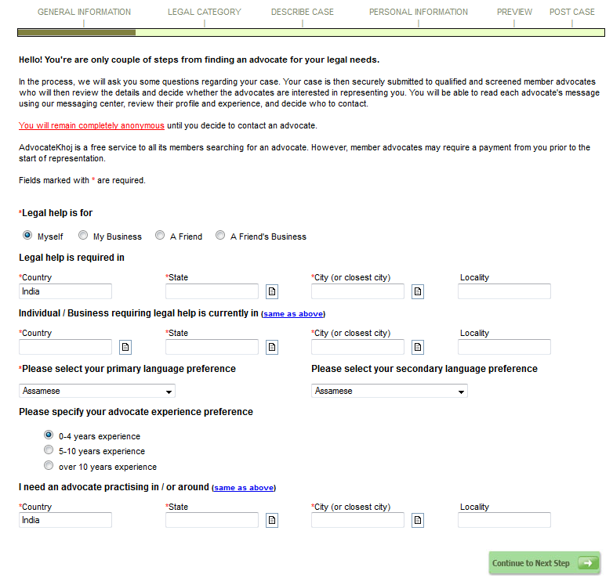

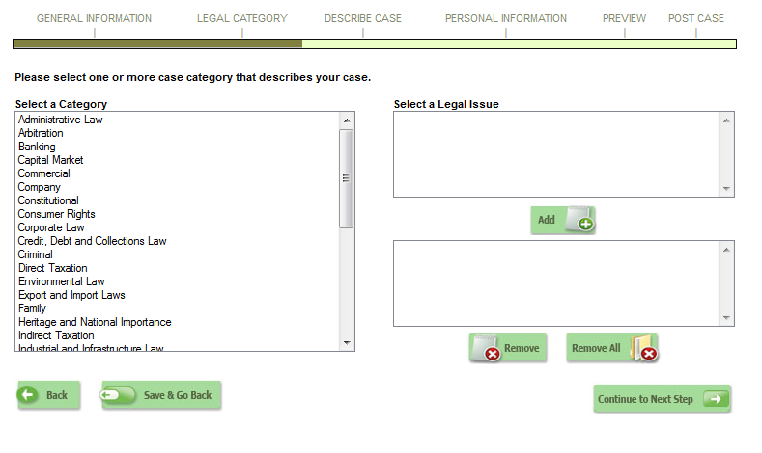

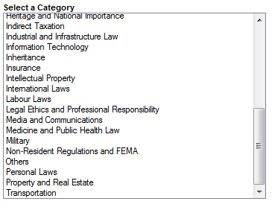

[**http://en.wikipedia.org/wiki/List_of_areas_of_law**](http://en.wikipedia.org/wiki/List_of_areas_of_law)

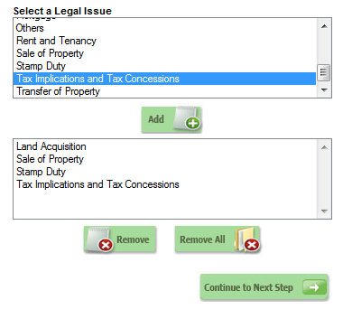

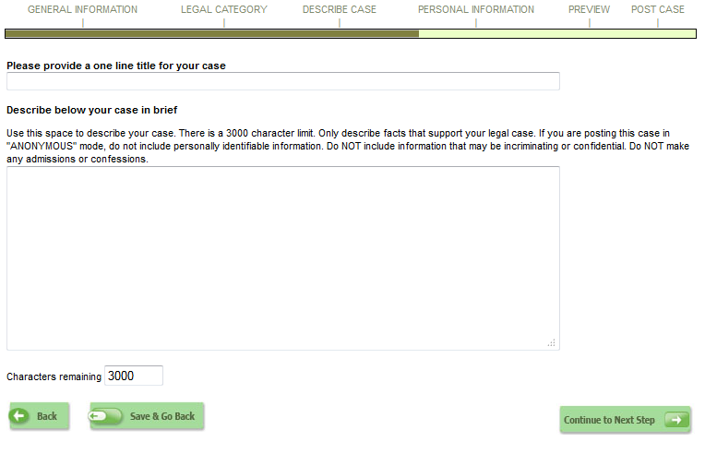

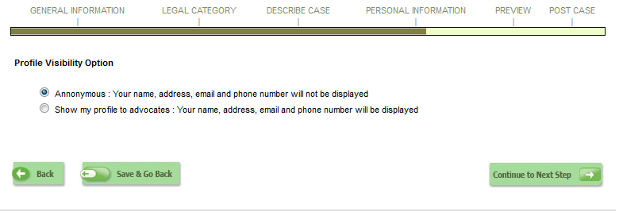

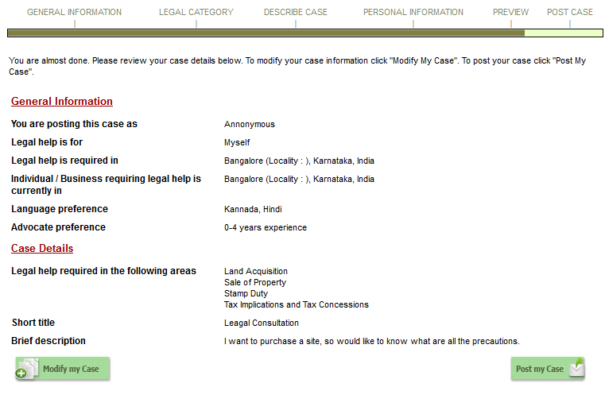

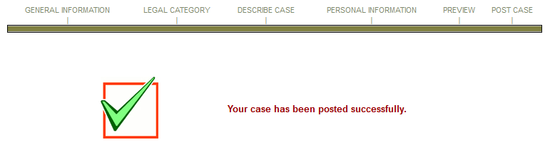



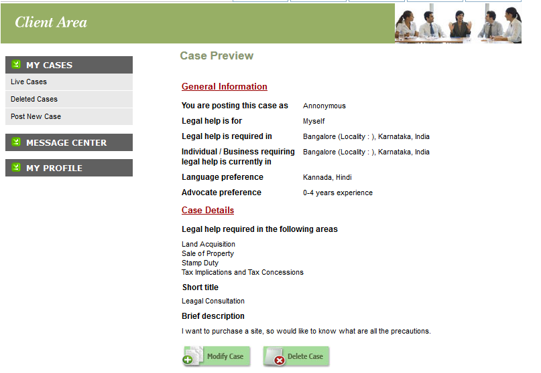

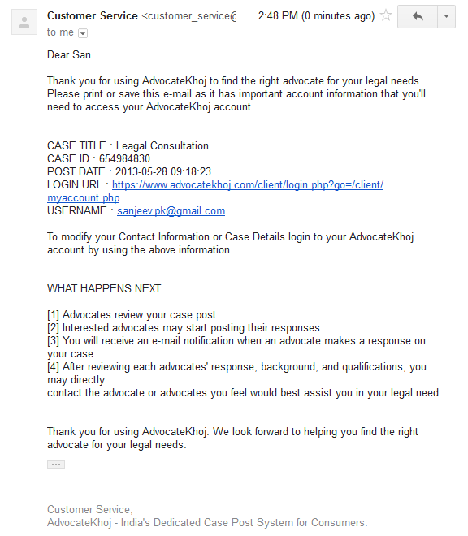

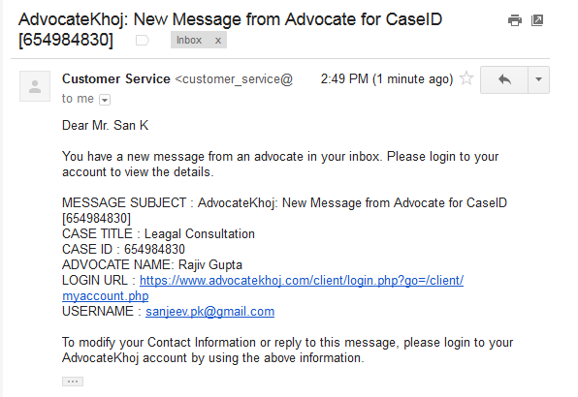

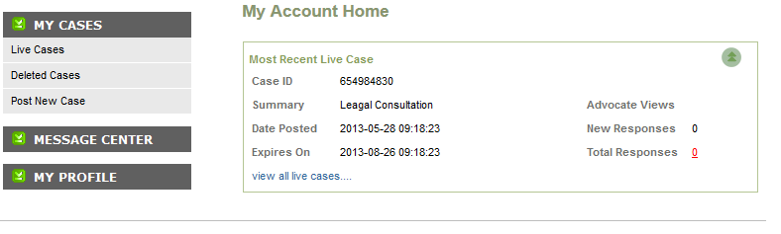



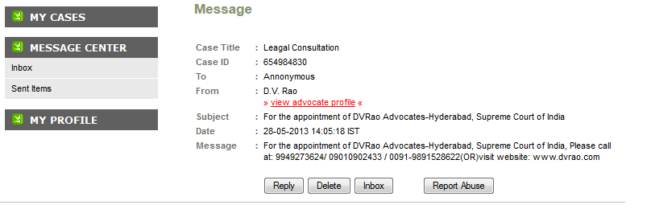

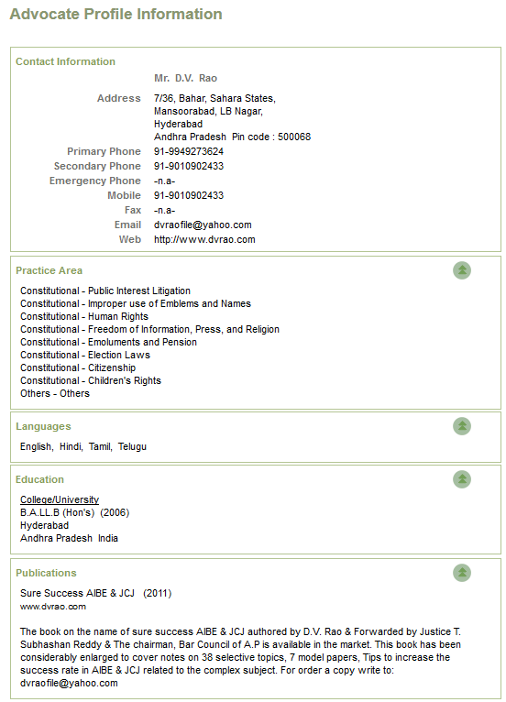

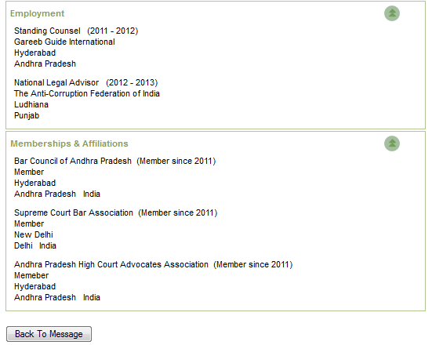

**List of Areas of Law:**

* [Administrative law](http://en.wikipedia.org/wiki/Administrative_law)
  + - Administration Justice
  + Other
* [Admiralty law](http://en.wikipedia.org/wiki/Admiralty_law) (or [maritime law](http://en.wikipedia.org/wiki/Maritime_law))
  + Alternative Dispute Resolution
  + Domestic Arbitration
  + International Commercial Arbitration
  + Mediation
  + Reconciliation
  + Others
* [Advertising law](http://en.wikipedia.org/w/index.php?title=Advertising_law&action=edit&redlink=1)
* [Agency law](http://en.wikipedia.org/wiki/Agency_law)
* [Alcohol law](http://en.wikipedia.org/wiki/Alcohol_law)
* [Alternative dispute resolution](http://en.wikipedia.org/wiki/Alternative_dispute_resolution)
* [Animal law](http://en.wikipedia.org/wiki/Animal_law)
* [Antitrust law](http://en.wikipedia.org/wiki/Antitrust_law) (or [competition law](http://en.wikipedia.org/wiki/Competition_law))
* [Appellate practice](http://en.wikipedia.org/w/index.php?title=Appellate_practice&action=edit&redlink=1)
* [Art law](http://en.wikipedia.org/wiki/Art_law) (or [art and culture law](http://en.wikipedia.org/wiki/Art_and_culture_law))
  + Ancient Monuments and Archaeological Sites
  + Antiquities and Art Treasures
  + Others
* [Aviation law](http://en.wikipedia.org/wiki/Aviation_law)
* [Banking law](http://en.wikipedia.org/wiki/Bank_regulation)
  + Bank Guarantees
  + Banking Ombudsman
  + Banking Regulation
  + Bankruptcy Law
  + Debt Recovery
  + Foreign Institutional Investors
  + Loans
  + Negotiable Instruments and Promissory Notes
  + Securitization
  + Others
* [Bankruptcy law](http://en.wikipedia.org/wiki/Bankruptcy_law) ([creditor debtor rights law](http://en.wikipedia.org/wiki/Creditor_debtor_rights_law) or [insolvency and reorganization law](http://en.wikipedia.org/wiki/Insolvency_and_reorganization_law))
* [Biotechnology law](http://en.wikipedia.org/w/index.php?title=Biotechnology_law&action=edit&redlink=1)
* [Business law](http://en.wikipedia.org/wiki/Business_law) (or [commercial law](http://en.wikipedia.org/wiki/Commercial_law)); also [commercial litigation](http://en.wikipedia.org/wiki/Commercial_litigation)
  + Agency Law
  + Business Collaborations
  + Carriage of Goods
  + Contract
  + Dishonor of Cheque
  + Foreign Exchange Management Act
  + Franchising
  + Monopolies and Restrictive Trade Practices
  + Partnership
  + Sale of Goods
  + Shares
  + Others
* [Business organizations law](http://en.wikipedia.org/wiki/Business_organizations_law) (or [companies law](http://en.wikipedia.org/wiki/Companies_law))
  + Amalgamation and Restructuring
  + Bankruptcy
  + Demergers
  + Incorporation of a Company
  + Investigation
  + Joint Ventures
  + Litigation against a Company
  + Management Team
  + Mergers and Acquisitions
  + Sick Companies
  + Winding up of Company
  + Others
* [Class action litigation](http://en.wikipedia.org/wiki/Class_action_litigation)/[Mass tort litigation](http://en.wikipedia.org/wiki/Mass_tort_litigation)
* [Communications law](http://en.wikipedia.org/wiki/Communications_law)
* [Computer law](http://en.wikipedia.org/wiki/Computer_law)
* [Conflict of law](http://en.wikipedia.org/wiki/Conflict_of_law) (or [private international law](http://en.wikipedia.org/wiki/Private_international_law))
* [Constitutional law](http://en.wikipedia.org/wiki/Constitutional_law)
  + Children's Rights
  + Citizenship
  + Discrimination Law
  + Election Laws
  + Emoluments and Pension
  + Freedom of Information, Press, and Religion
  + Human Rights
  + Improper use of Emblems and Names
  + Public Interest Litigation
  + Others
* [Construction law](http://en.wikipedia.org/wiki/Construction_law)
* [Consumer law](http://en.wikipedia.org/wiki/Consumer_law)
  + Consumer Protection Act.
  + Monopolistic and Restrictive Trade Practice Act
  + Standard Weight and Measures
  + Others
* [Contract law](http://en.wikipedia.org/wiki/Contract_law)
* [Copyright law](http://en.wikipedia.org/wiki/Copyright_law)
* [Corporate law](http://en.wikipedia.org/wiki/Corporate_law) (or [company law](http://en.wikipedia.org/wiki/Company_law)), also [corporate compliance law](http://en.wikipedia.org/wiki/Corporate_compliance_law) and [corporate governance law](http://en.wikipedia.org/wiki/Corporate_governance_law)
  + Arbitral and Court Proceedings
  + Arbitration
  + Society Act
  + Trust
  + Others
* **Credit, Debt and Collection**
  + Credit, Debt and Collection
* [Criminal law](http://en.wikipedia.org/wiki/Criminal_law)
  + Adulteration of Drugs
  + Adultery
  + Anticipatory Bail
  + Arrest
  + Bail
  + Causing Death by Negligence
  + Child Abuse
  + Concealment of Previous Marriage
  + Criminal Misappropriation of Property
  + Criminal Procedure Code
  + Defamation
  + Defense of Property
  + Domestic Violence
  + Dowry Deaths
  + Drugs and Narcotic
  + Economic Offences
  + Extortion
  + FIR
  + Food Adulteration
  + Forgery
  + Indian Evidence Act
  + Indian Penal Code
  + Investigation
  + Juvenile Law
  + Kidnapping
  + Nuisance
  + Obscene Acts and Songs
  + Prostitution
  + Rape
  + Rash Driving
  + Right of Private Defense
  + Sale of Obscene Books
  + Selling Goods Marked with Counterfeit Property
  + Sexual Harassment
  + Summons
  + Theft
  + Others
* [Cryptography law](http://en.wikipedia.org/wiki/Cryptography_law)
* [Cultural property law](http://en.wikipedia.org/wiki/Cultural_property_law)
* [Custom (law)](http://en.wikipedia.org/wiki/Custom_%28law%29) **or Export & Import Laws**
  + Customs Duties and Cases
  + Exim Policy
  + Export Benefits and Incentives
  + Export Units
  + Foreign Trade Policy
  + Others
* [Cyber law](http://en.wikipedia.org/wiki/Cyber_law)
* [Defamation](http://en.wikipedia.org/wiki/Defamation)
* [Derivatives and futures law](http://en.wikipedia.org/w/index.php?title=Derivatives_and_futures_law&action=edit&redlink=1)
* [Drug control law](http://en.wikipedia.org/wiki/Drug_control_law)
* [Elder law](http://en.wikipedia.org/wiki/Elder_law)
* [Employee benefits law](http://en.wikipedia.org/w/index.php?title=Employee_benefits_law&action=edit&redlink=1) ([ERISA](http://en.wikipedia.org/wiki/ERISA))
* [Employment law](http://en.wikipedia.org/wiki/Employment_law)
* [Energy law](http://en.wikipedia.org/wiki/Energy_law)
* [Entertainment law](http://en.wikipedia.org/wiki/Entertainment_law)
* [Environmental law](http://en.wikipedia.org/wiki/Environmental_law)
  + Air Pollution
  + Environment Protection
  + Natural Resources
  + Water Pollution
  + Wild life Protection
  + Others
* [Equipment finance law](http://en.wikipedia.org/w/index.php?title=Equipment_finance_law&action=edit&redlink=1)
* [Evidence](http://en.wikipedia.org/wiki/Evidence)
* [Family law](http://en.wikipedia.org/wiki/Family_law)
  + Adoption
  + Births, Deaths and Marriages Registration
  + Custody
  + Divorce and Maintenance
  + Dowry
  + Foreign Marriage
  + Guardianship Law
  + Inter Country Adoption
  + Marriage
  + Others
* [FDA law](http://en.wikipedia.org/w/index.php?title=FDA_law&action=edit&redlink=1)
* [Financial services regulation law](http://en.wikipedia.org/wiki/Financial_services_regulation_law)
* [Firearm law](http://en.wikipedia.org/wiki/Firearm_law)
* [Food law](http://en.wikipedia.org/wiki/Food_law)
* [Franchise law](http://en.wikipedia.org/w/index.php?title=Franchise_law&action=edit&redlink=1)
* [Gaming law](http://en.wikipedia.org/wiki/Gaming_law)
* [Health law](http://en.wikipedia.org/wiki/Health_law)
* [Health and safety law](http://en.wikipedia.org/wiki/Health_and_safety_law)
* [Health care law](http://en.wikipedia.org/wiki/Health_care_law)
* **Industrial and Infrastructure Law**
  + Construction
  + Energy and Electricity
  + Others
* **Inheritance Law**
  + Indian Hindu Succession Act
  + Inheritance in Muslims
  + Probate of Will
  + Others
* [Immigration law](http://en.wikipedia.org/wiki/Immigration_law)
* [Insurance law](http://en.wikipedia.org/wiki/Insurance_law)
  + Fire Insurance
  + Health Insurance
  + Life Insurance
  + Marine Insurance
  + Motor Insurance
  + Others
* [Intellectual property law](http://en.wikipedia.org/wiki/Intellectual_property_law)
  + Copyright
  + Designs
  + Intellectual Property Rights
  + Patents
  + Trademarks
  + Unfair Competition
  + Others
* [International law](http://en.wikipedia.org/wiki/International_law)
* [International trade and finance law](http://en.wikipedia.org/wiki/International_trade_and_finance_law)
* [Internet law](http://en.wikipedia.org/wiki/Internet_law) **or Information Technology Law or Cyber Law**
  + Convergence
  + Cyber Crime
  + Digital Cash
  + Domain Name Disputes
  + Electronic Payment Systems
  + Online Contracts
  + Right to Privacy
  + Others
  + Digital Images
  + Porn or Nude
  + Others
* [Labor law](http://en.wikipedia.org/wiki/Labor_law) (or [Labour law](http://en.wikipedia.org/wiki/Labour_law))
* [Land use & zoning law](http://en.wikipedia.org/w/index.php?title=Land_use_%26_zoning_law&action=edit&redlink=1)
* [Litigation](http://en.wikipedia.org/wiki/Litigation)
* [Martial law](http://en.wikipedia.org/wiki/Martial_law)
* [Media law](http://en.wikipedia.org/wiki/Media_law)
* [Mergers & acquisitions law](http://en.wikipedia.org/w/index.php?title=Mergers_%26_acquisitions_law&action=edit&redlink=1)
* [Military law](http://en.wikipedia.org/wiki/Military_law)
* [Mining law](http://en.wikipedia.org/wiki/Mining_law)
* [Juvenile law](http://en.wikipedia.org/wiki/Minor_%28law%29)
* [Music law](http://en.wikipedia.org/wiki/Music_law)
* [Mutual funds law](http://en.wikipedia.org/w/index.php?title=Mutual_funds_law&action=edit&redlink=1)
* [Nationality law](http://en.wikipedia.org/wiki/Nationality_law)
* [Native American law](http://en.wikipedia.org/w/index.php?title=Native_American_law&action=edit&redlink=1)
* [Obscenity law](http://en.wikipedia.org/wiki/Obscenity_law)
* [Oil & gas law](http://en.wikipedia.org/w/index.php?title=Oil_%26_gas_law&action=edit&redlink=1)
* [Parliamentary law](http://en.wikipedia.org/wiki/Parliamentary_law)
* [Patent law](http://en.wikipedia.org/wiki/Patent_law)
* [Poverty law](http://en.wikipedia.org/wiki/Poverty_law)
* [Privacy law](http://en.wikipedia.org/wiki/Privacy_law)
* [Private equity law](http://en.wikipedia.org/w/index.php?title=Private_equity_law&action=edit&redlink=1)
* [Private funds law](http://en.wikipedia.org/w/index.php?title=Private_funds_law&action=edit&redlink=1) / [Hedge funds law](http://en.wikipedia.org/w/index.php?title=Hedge_funds_law&action=edit&redlink=1)
* [Procedural law](http://en.wikipedia.org/wiki/Procedural_law)
* [Product liability litigation](http://en.wikipedia.org/w/index.php?title=Product_liability_litigation&action=edit&redlink=1)
* [Property law](http://en.wikipedia.org/wiki/Property_law)
* [Public health law](http://en.wikipedia.org/wiki/Public_health_law)
* [Railroad law](http://en.wikipedia.org/w/index.php?title=Railroad_law&action=edit&redlink=1)
* [Real estate law](http://en.wikipedia.org/wiki/Real_estate_law)
* [Securities law](http://en.wikipedia.org/wiki/Securities_law) / [Capital markets law](http://en.wikipedia.org/wiki/Capital_markets_law)
* [Social Security disability law](http://en.wikipedia.org/w/index.php?title=Social_Security_disability_law&action=edit&redlink=1)
* [Space law](http://en.wikipedia.org/wiki/Space_law)
* [Sports law](http://en.wikipedia.org/wiki/Sports_law)
* [Statutory law](http://en.wikipedia.org/wiki/Statutory_law)
* [Tax law](http://en.wikipedia.org/wiki/Tax_law)
  + Appeals
  + Deductions and Rebate
  + Fringe Benefit Tax
  + Income Tax
  + Revenue Recovery
  + Settlement of Cases
  + Transfer Pricing
  + Wealth Tax
  + Central Sales Tax
  + Excise Service Tax
  + Service Tax
  + Value Added Tax
  + Others
* [Technology law](http://en.wikipedia.org/wiki/Technology_law)
* [Timber law](http://en.wikipedia.org/w/index.php?title=Timber_law&action=edit&redlink=1)
* [Tort law](http://en.wikipedia.org/wiki/Tort_law)
* [Trademark law](http://en.wikipedia.org/wiki/Trademark_law)
* [Transport law](http://en.wikipedia.org/wiki/Transport_law) / [Transportation law](http://en.wikipedia.org/wiki/Transportation_law)
* [Trusts & estates law](http://en.wikipedia.org/wiki/Trusts_%26_estates_law)
* [Utilities Regulation](http://en.wikipedia.org/w/index.php?title=Utilities_Regulation&action=edit&redlink=1)
* [Venture capital law](http://en.wikipedia.org/w/index.php?title=Venture_capital_law&action=edit&redlink=1)
* [Water law](http://en.wikipedia.org/wiki/Water_law)